Layout Analysis

(OCR)

COMPUTER VISION

Dr.Aziz Qaroush

Motasem Diab #1162106
Nisreen

BIRZEIT
November – 11 – 2020

Abstract

Page segmentation is the task of decomposing document scans into many different regions such as text, images, tables and graphs. It is the first step in document image recognition and it is still a challenging problem due to the variety of possible document layouts. In this thesis we study an effective method for accomplish the page segmentation phase and improve state of the art in this task. After studying many papers in this field, we introduced a new method that take parts from everywhere. Our method is easy to understand and contains three main stages, firstly, transfer the image to binary image, then filter the binary to text and non-text binary images, finally, reforming the binary to make blocks that can results a good contours. In this project we will use PRImA Lay- out Analysis Dataset.

 | Introduction:  In the beginning of the 90’s, metho-dlogies, algorithms and systems were invented and developed for document image analysis in order to extract in- formation from document images in a ”human-like” way. Extracting inform-ation from a document refers to locating and extracting lines, photos or text region [1].  There are many advantages of using paper documents, and most people prefer to read paper documents rather than electronic one. However, it also brings certain difficulties as well; storing them would be very cumbe-rsome and time-consuming. It will cause more difficulties in the develop-ment of artificial intelligence for machines, an urgent need for the human. It would be possible to solve the problem if paper documents could be converted to electronic documents auto-matically so that machines could read and understand the information [2] .  Related Works:  In recent years, many approaches have been proposed for page segmentation, but they are categorized into four main types: bottom-up, top-down, hybrid, and multi-scale resolution method. | 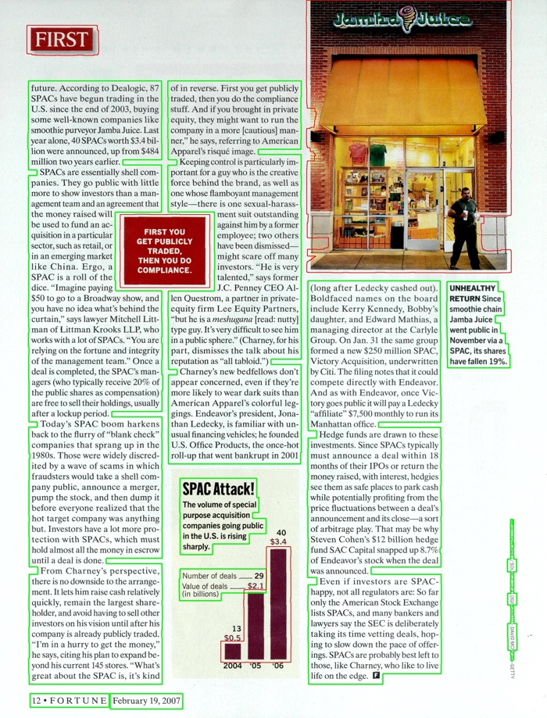  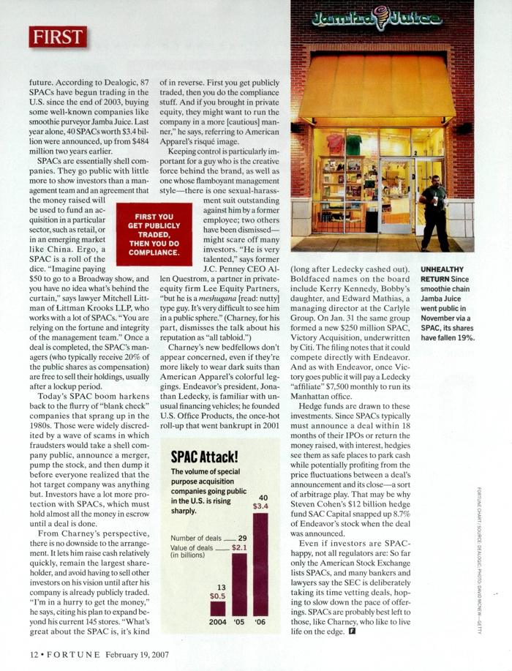

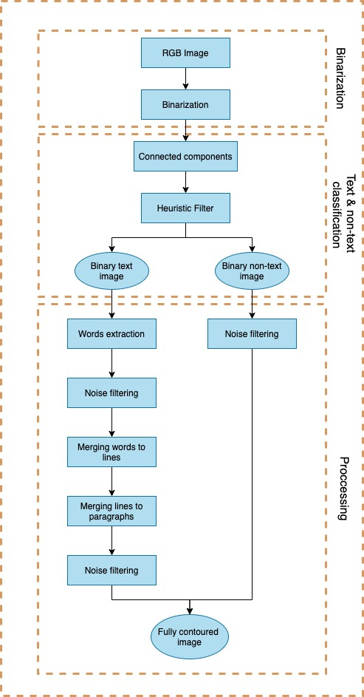
OUR DESIGN:

Our introduced model consist of three main stages, RGB to binary transformation, text and non-text classification, Processing text and non-text with noise removing to extract contours for each then draw contours on the original image [Fig. 1-2].

Binarization:

In this stage the main purpose is to convert the image to binary level. Reading the image as RGB and save it to future use “draw the final contours on it” is the first step, then convert the image to Gray level, then smoothing the image to fill any gaps. Finally, we used “OTSUS thresholding” to convert it to binary [Fig. 1-1] .
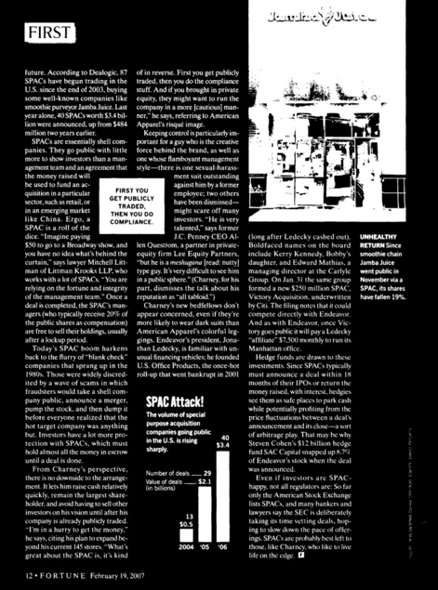
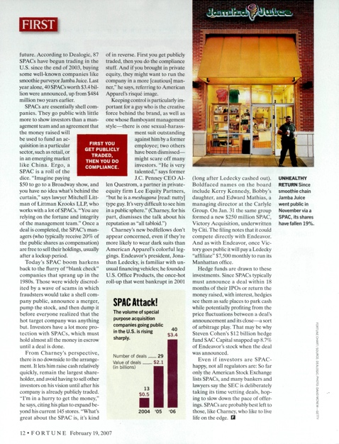
Figure ‎1-1: the original image is on the left, the right image is the binary image
Figure ‎1-2 flow chart of our model

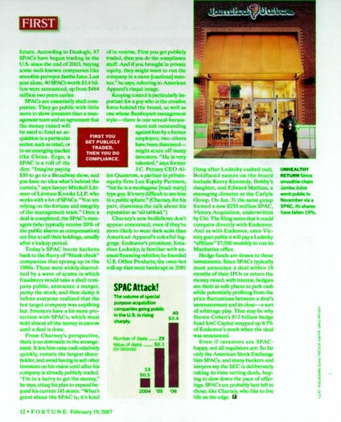
Text and non-text classification:

2.1- Connected Components (CC) analysis:

In this second step we aim to extract and analyze the connected components (CC) present in the binary document resulting from the first phase. Connected components labelling is the process that extracts all the pixels that are connected and have the same value, it assigns these to a separate components. We’ve used the “find contours” technique that works to extract each group of connected white pixel as CC.
Figure ‎2-1 connected components contoured in green

Once we have extracted the connected components [Fig. 2-1] we start the analysis to obtain, for each component, the self-related attributes. Let Lcc be the list of all the connected the components, and be CCi is the ith connected component of f. For every CCi we compute and associate the following set of features:

- B(CCi) : is the bounding box, i.e. the smallest rectangle which circum- scribes the connected component, of CCi stored as Xmin, Ymin, Xmax, Ymax .

- CCarea(CCi): is the area of the CCi, that is the number of non-zero pixels.

- Bsize(CCi): is the area of B(CCi), computed as:
Bsize(CCi) = (Xmax − Xmin) ∗ (Ymax − Ymin)

- CCdens(CCi): is the ratio between the CCarea(CCi) and the Bsize(CCi), computed as:
CCdens(CCi) = CCarea (CCi) / Bsize(CCi)

- CCins(CCi): is the list of B(CCj), i != j located inside the B(CCi)

- CCratio(CCi) : is the aspect ratio, that in a rectangle is the ratio of its longer side to its shorter side, of the bounding box of the CCi , computed as:
CCratio(CCi)= min(Wi, Hi) / max(Wi, Hi)
Where, Wi = Xmax − Xmin, and Hi = Ymax − Ymin

2.2- Heuristic Filter:

The use of heuristic conditions or threshold values is common in image processing. These are used to speed up processing and prune some individual cases. Heuristics conditions must be precise and strict because they have a strong influence on the precision of the successive steps of the algorithm.

A connected component can be considered non-text if one of the following features obtained:
- CCarea < Tarea = 6
- CCdens < Tdens = 0.15
- CCratio < Tratio = 0.06
- CCins > Tins = 4

Applying the heuristic filter on the list of all CCs introduce a two lists, one for CCs that can be classified as text, another for CCs that can be classified as non-text. To be benefited from this step we made two binary images for both text and non-text by one of the following methods:

Method1:
- Walk through all the pixels in the binary image,
- If the pixel belongs to any component in the list of text CCs then put this pixel in the text binary, and vice versa.

Method2:
- Make a two copies of the binary image,
- In the first copy, contouring the non-text and fill it black introducing a binary text and vice versa.

The output of this stage is a binary text image [Fig2-3] and binary non-text image [Fig2-4]. At this times we can see the output from another perspective by contouring the text CCs in green and non-text CCs in red [Fig2-2]

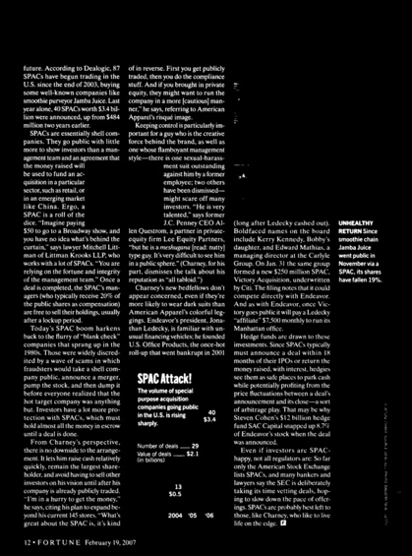
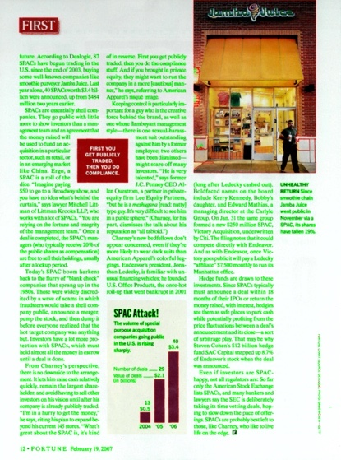
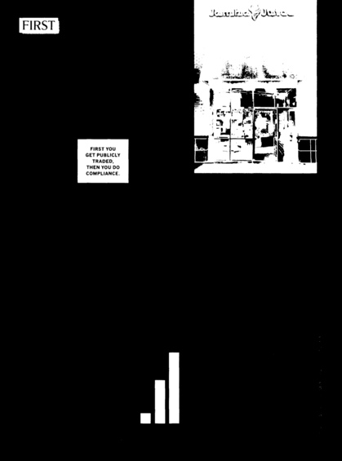

Figure ‎2-2 text CCs in green, non-text in red
Figure ‎2-3 binary text
Figure ‎2-4 : non-text binary

Processing:

In this stage we will process the two images introduced from the previous stage.

Binary text processing:

3.1.A- Word extraction:
Firstly, in order to merging letters together we made a horizontal dilation (dilation with kernel “2*9” ) then take the rectangle contour for each as a new CC with calculation of its features as shown in CC section above (sec2.1). The result of this section is CCs of words or bigger.

3.1.B- Noise Filtering:
Looping on the new CCs list resulted from previous section(3.1.A) removing the CCs with CCdens < Ldens = 0.4 or CCsize < Lsize = 500 .

3.1.C- Merging words to lines:
Another loop on the list resulted from section(3.1.C) to merge two adjacent CCs in one CC, the two adjacent CCs can be recognized if they applied all the following condition: (let Xmin, Ymin, Xmax, Ymax, respectively the leftmost, the topmost, the rightmost and the lowermost coordinate)

- The absolute difference between Xmin of (CCi+1) and Xmax of (CCi) < Xthresh = 20
- The absolute difference between Ymin of (CCi+1) and Ymin of (CCi) < Ythresh = 20
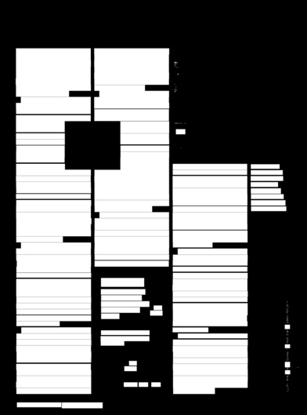
If the previous is applied then make a new CC combines the two adjacent CCs, the new CC coordinates will be as the following:
Xmin (CCnew) = min{ Xmin (CCi) , Xmin (CCi+1) }
Ymin (CCnew) = min{Ymin (CCi) , Ymin (CCi+1) }
Xmax (CCnew) = max{Xmax (CCi) , Xmax (CCi+1) }
Ymax (CCnew) = max{Ymax (CCi) , Ymax (CCi+1) }

This stage will result a list of connected components of fully
lines [Fig3-1].
Figure ‎3-1
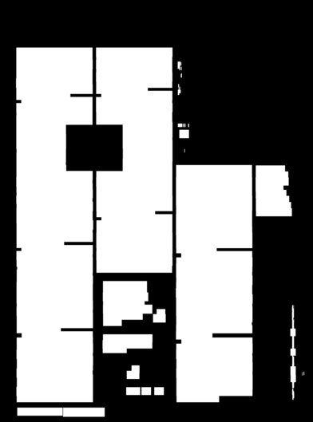

3.1.D- Merging lines to paragraphs:
This is an easy step, taking the list resulted from section(3.1.C) drawing rectangle contour on each CC filled with white on the binary text image from section(2.2) resulting a new image, making a horizontal dilation (kernel “9*1) will result a binary image fully white filled on text regions, each column paragraphs will stay independent and if there is a horizontal gap between paragraphs will stay as it is [Fig].

Figure ‎3-2 fully text with noise

3.1.E- Noise Filtering:
This is the last step in text contouring, just walk through on the list resulted from section(3.1.D) remove CC with area less than a specific threshold = 10k result of this will be an acceptable text contouring [Fig] from another perspective on the original image we ensure that [Fig]
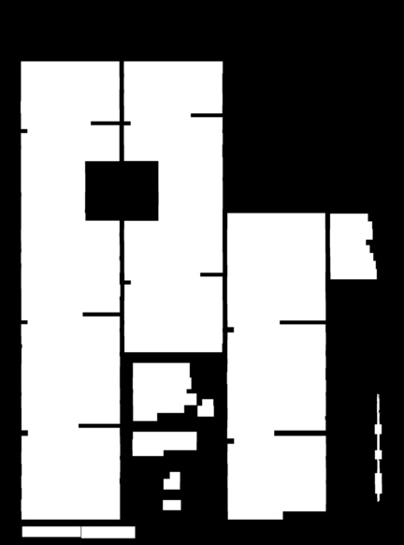
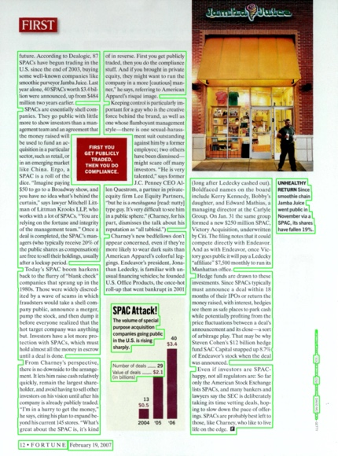

Figure ‎3-3 fully text contoured on original image

Figure ‎3-4 fully text without noise in binary

Binary non-text processing:

In this section, we made a simple morphological operations (closing with “6*6” kernel) then another one (dilation with “9*13” kernel), after that we just loop on non-text CCs list removing the contours with size less than threshold = 30K, this is based on there is no non-text photo with size less than this threshold.

Fully Contoured Image:

In assembling the output of the two previous section (3.1 & 3.2), we’ve take the two lists, then contouring all text CCs by green line, and non-text CCs by red line [Fig].
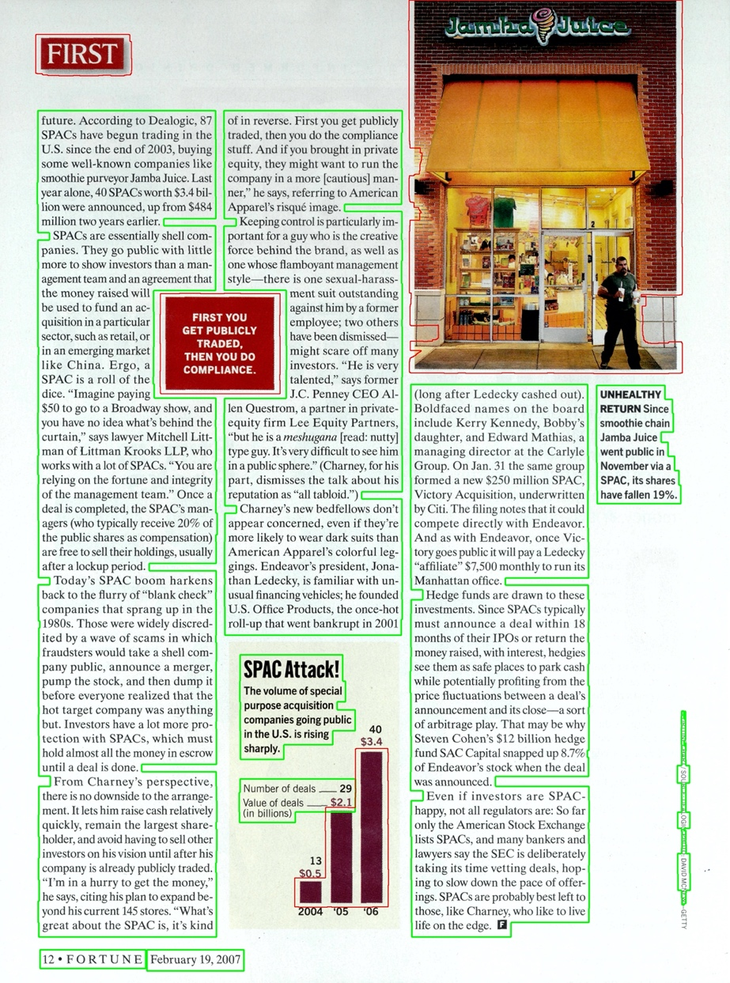

Figure ‎3-5 Output Image, text in green, non-text in red

Results:
The following are more contoured images:

Future Work:

In the future we aim to improve our algorithm by non-text contouring method and classify them to tables, graphs, images ..etc. Another thing we want to work on it is partitioning the text to sub paragraphs, the first step of this is by divide the text binary image to lines with fixed height (the median of lines) then comparing the line width to decide where the paragraph ends, [Fig 3-1] shows the first step of this.
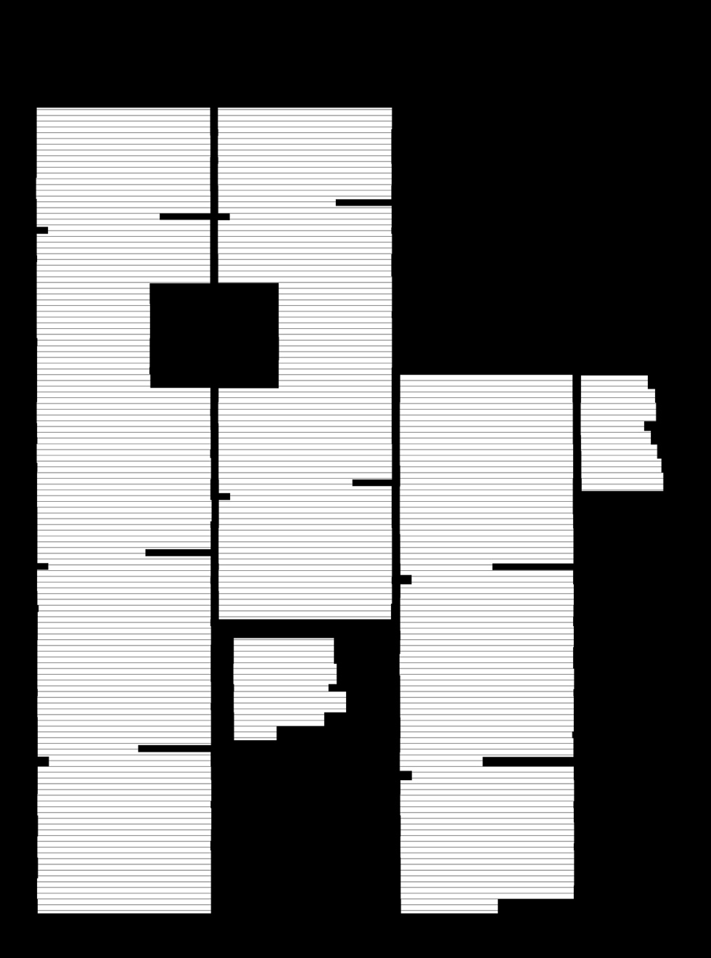
Figure ‎3-1 future work

Conclusion

References

[1] https://www.cse.usf.edu/~r1k/DocumentImageAnalysis/DIA.pdf (10.11.2020)

[2]: Page segmentation using minimum homogeneity algorithm and adaptive mathematical morphology

